TASK 1 – MATHEMATICS – WHY MATHS IN CODING?

1.A

OUTPUT:

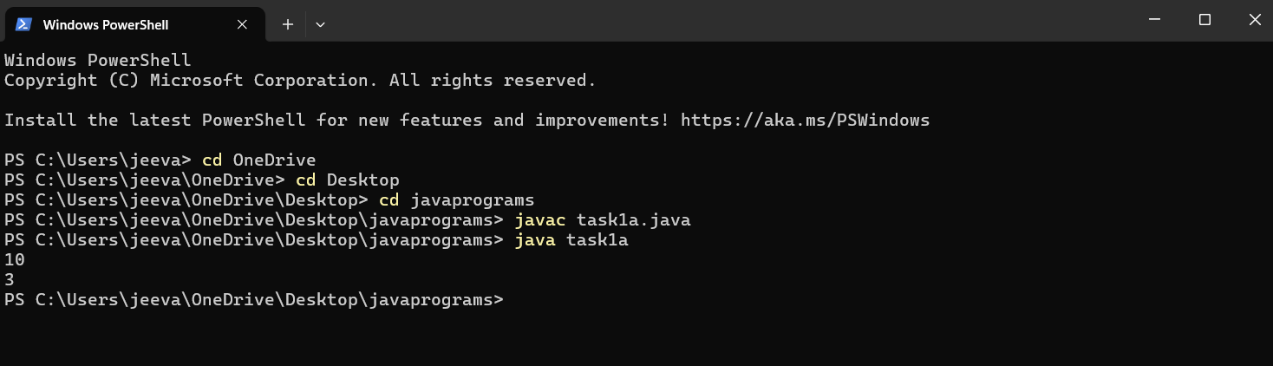

1.B

OUTPUT:

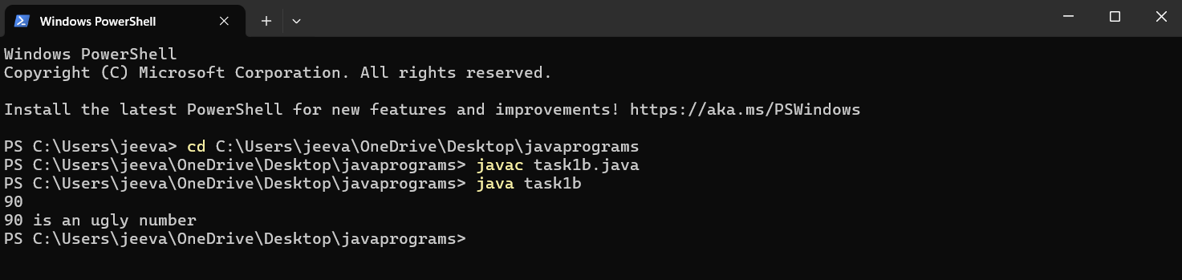

1.C

OUTPUT:

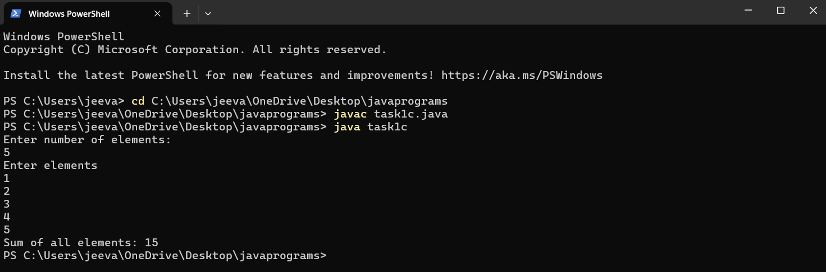

TASK NO: 2 :- ADVANCED CONCEPTS ON ARRAY :

2.A

OUTPUT:

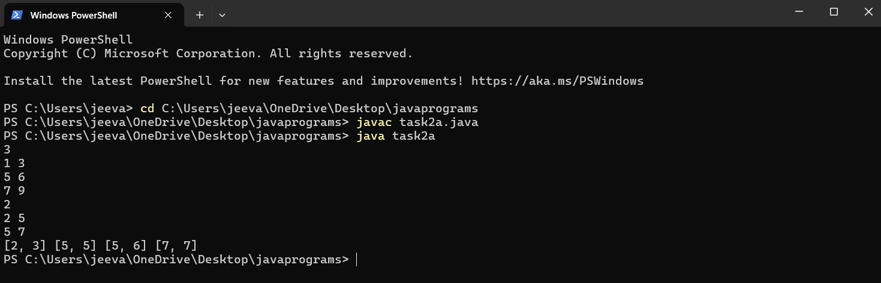

2.B

OUTPUT:

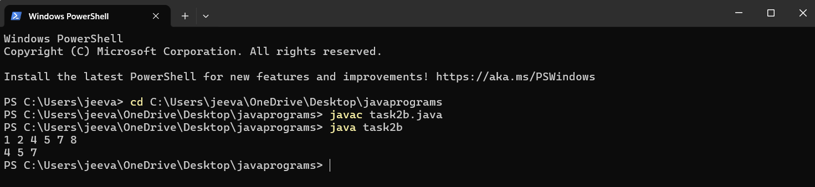

2.C

OUTPUT:

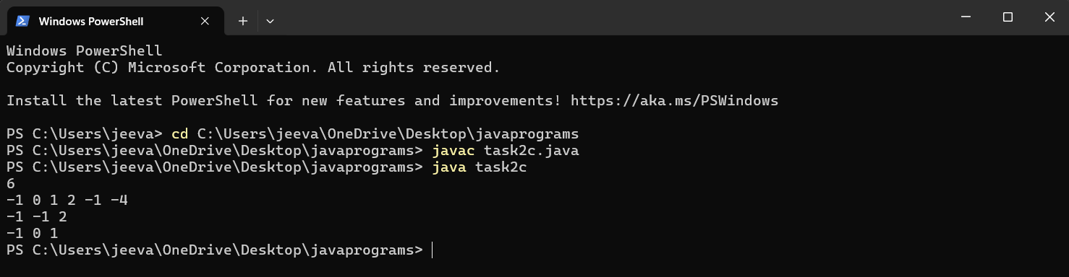

TASK 3 : ADVANCED CONCEPTS ON STRINGS

3.A

OUTPUT:

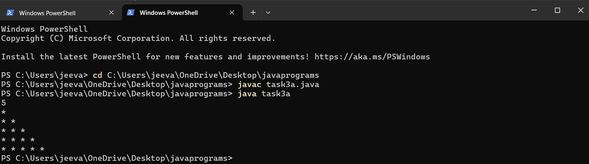

3.B

OUTPUT:

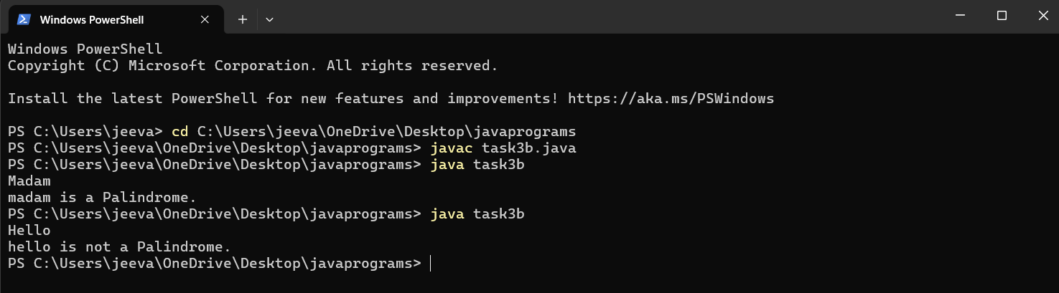

3.C

OUTPUT:

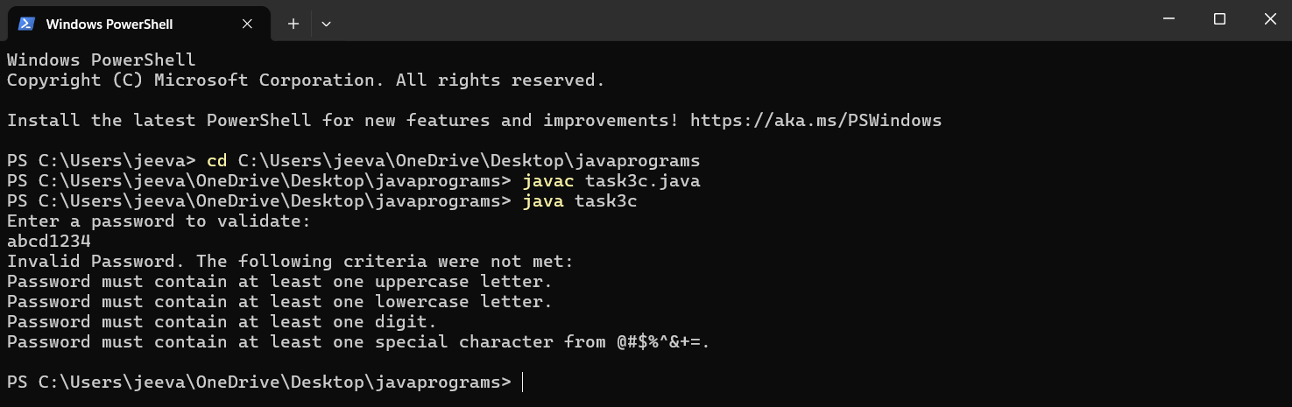

TASK 4 : STACK AND QUEUES

4.A

OUTPUT:

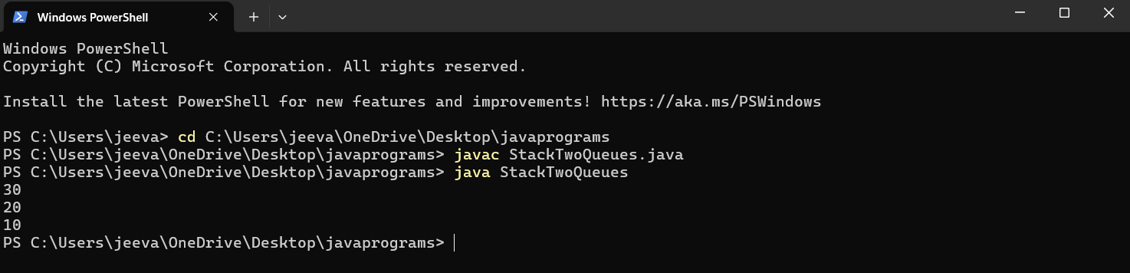

4.B

OUTPUT: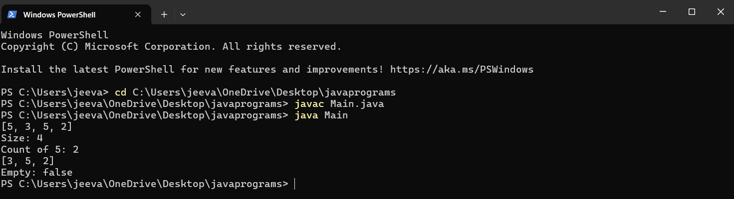

4.C

OUTPUT:

